PROBLEM STATEMENT:

|  |  |
| --- | --- |
| **Date** | 25/09/2022 |
| **Team ID** | PNT2022TMID26096 |
| **Project Name** | Signs with Smart connectivity for Better Road Safety |
| **Maximum Marks** | 2 marks |

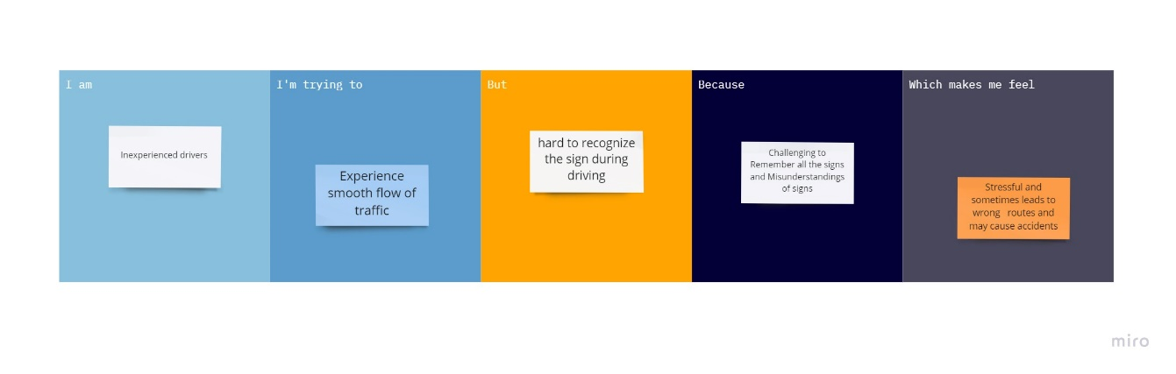

|  |  |  |  |  |  |
| --- | --- | --- | --- | --- | --- |
| **Problem Statement (PS)** | **I am (Customer)** | **I am trying to** | **But** | **Because** | **Which makes me feel** |
| PS-1 | Inexperienced drivers | Experience smooth flow of traffic | Find it hard to recognize the sign during driving | Challenging to Remember all the signs and Misunderstandings of signs | Stressful and sometimes leads to wrong routes and may cause accidents |
| PS-2 | Aging Drivers | Read all the signs | Difficulty in seeing road signs | Poor Visibility | Misinterpret Roadside Signage or miss it |